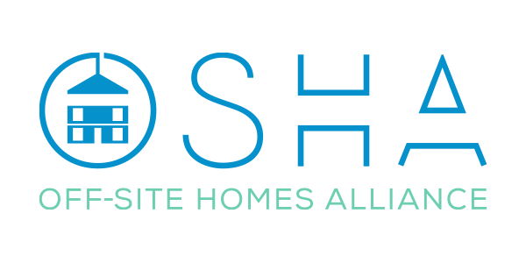

Your Company Name:

Your Main Point of Contact:

Their Email Address:

Pre-Tender Market Engagement Questions

- Your System

Please can you describe your system, in terms of MMC Category, material, and in terms of product (eg: a Cat 2 MMC open panel timber system for housing / Cat 1 MMC volumetric Light Gauge Steel product for apartments.)

- The MMC Industry Standards & Regulatory Processes

Do you consider that the Regulatory and Standards framework for the MMC/Offsite DfMA industry process(es), in terms of requirements and compliance, provides a robust and level playing field? (Please expand your answer and rationale for both yes and no responses, and if possible, please explain how this could be improved).

- The Collaborative DfMA Process (DESIGN)

Do you believe that our Industry has an effective and well-coordinated design process within the factory environment, across the many categories of MMC propositions, and one that connects (clearly) with the fully integrated delivery team on a project? (Please expand your answer and rationale for both yes and no responses, and if possible, please explain how this could be improved).

- The Collaborative DfMA Process (MANUFACTURE)

Do you believe that our industry’s manufacturing facilities (generally) for Cat 1 (full volumetric), Cat 2 (panellised) and Cat 5 (e.g. Pods) are operating in a robust and efficient manner at the moment, both from a supply and demand perspective? (Please expand your answer and rationale for both yes and no responses, and if possible, please explain how this could be improved).

- The Collaborative DfMA Process (ASSEMBLY/INSTALLATION)

Do you believe that our industry has (in general) robust logistics and installation management processes, that allow a seamless delivery of offsite (Cat 1) and MMC Cat 2/5 type systems, to be delivered and erected without issues (site restrictions permitting)? (Please expand your answer and rationale for both yes and no responses, and if possible, please explain how this could be improved).

- The MMC Certification & Warranty Schemes

Where certification (e.g. BBA, KIWA, BOPAS, NHBC Accepts etc) type compliance is chosen (or required), and also warranty provision (e.g. NHBC, BLP (Aviva), Premier, Checkmate etc), do you consider this to be clear, and a robust approach to ensuring a safeguarded final product for the client? (Please expand your answer and rationale for both yes and no responses, and if possible, please explain how this could be improved).

- Internal Business (IMS/ QA) System Processes for MMC

Do you consider that most (if not all) MMC/Offsite manufacturing organisations will have robust business process management systems (and / or manuals) and / or a regulated Quality Management System [QMS] (e.g. ISO 9001), to support their MMC/Offsite propositions, across MMC categories 1, 2 and 5? (Please expand your answer and rationale for both yes and no responses, and if possible, please explain how this could be improved).

- Vertical Integration Management Process for MMC

Do you consider it to be the case that on all the projects you have been involved with, there is a very clear and structured process of communication and management, for the effective use of MMC/Offsite technologies? (Please expand your answer and rationale for both yes and no responses, and if possible, please explain how this could be improved).

- MMC Securitisation

Finally, in the absence of a ‘full commitment’ from finance organisations to securitise assets for future lending, when built out of MMC/Offsite technologies (especially in the Housing Association sector), how do you believe this situation can be resolved, to demonstrate improved trust to these institutions, that still require further proof of delivery and performance over the normal lifetime of domestic use, single and multi-family properties? (Please expand your answer and rationale for both yes and no responses, and if possible, please explain how this could be improved).

End of Questions
Thank you for your valuable time.

Please submit your completed form to the OSHA Project Management Office
via mike.ormesher@offsiteha.org

Deadline for all responses is 30th November 2021. Please also feel free to use the email to add anything to the response that you feel necessary.

